AI Capstone Project Proposal Concept

Jackson McKeigue
AI 5273: AI Capstone Project
Carlos A. Escobar
3/15/26

Problem Statement
Pneumonia is one of the leading causes of respiratory illness worldwide and remains a major public health concern. Early and accurate diagnosis is critical because delayed treatment can significantly increase morbidity and mortality rates. Chest X-ray imaging is one of the most common diagnostic tools used to identify pneumonia; however, interpreting these images requires specialized radiology expertise and can be time-consuming in busy healthcare environments. In many hospitals, especially those in under-resourced regions, radiologists may face high workloads or limited staffing, which can delay diagnoses and increase the risk of human error.
Artificial intelligence (AI) systems capable of analyzing medical images present a promising opportunity to improve diagnostic efficiency. Recent research has demonstrated that machine learning models can automatically identify patterns associated with pneumonia in chest X-ray images with high accuracy. Studies have shown that AI models trained on radiographic images can achieve diagnostic sensitivity around 88% and specificity around 90%, approaching the performance of professional radiologists (Essa et al., 2025).
The purpose of this capstone project is to develop a prototype AI model capable of detecting pneumonia from chest X-ray images using supervised machine learning techniques. The system will analyze publicly available medical image datasets and classify X-rays as either normal or pneumonia-positive. The scope of this project is limited to model development, testing, and evaluation rather than real clinical deployment. The goal is to demonstrate how AI can assist healthcare professionals by acting as a decision-support tool that helps prioritize cases requiring further examination.

Why AI is a Viable Solution
Artificial intelligence, particularly deep learning models such as convolutional neural networks (CNNs), is highly effective for analyzing image data. CNNs are designed to automatically learn visual features from images and have been widely used in medical imaging applications, including pneumonia detection (Siddiqi et al., 2024). Unlike traditional computer vision approaches, CNNs can automatically extract features such as lung opacity, tissue patterns, and abnormalities without requiring manual feature engineering.
Research has shown that deep learning models trained on chest X-ray datasets can accurately classify pneumonia and other respiratory conditions, improving diagnostic speed and assisting radiologists in clinical decision-making (Usman et al., 2025). Additionally, AI can function as a “second reader,” improving radiologist performance and increasing sensitivity when identifying abnormalities (Essa et al., 2025).
This project aligns with several phases of the AI life cycle, including:
- Problem Definition – identifying the need for faster and more accurate pneumonia detection.
- Data Collection & Preparation – using publicly available chest X-ray datasets to train the model.
- Model Development – implementing a CNN-based architecture for image classification.
- Model Evaluation – measuring model performance using metrics such as accuracy, precision, recall, and F1 score.
- Conceptual Deployment – demonstrating how such systems could support clinical decision-making in healthcare settings.
Through the phases, the project will demonstrate how AI systems can augment human expertise rather than replace healthcare professionals.

Stakeholders and Expected Benefits
Several key stakeholders are directly affected by the development and sue of AI-based pneumonia detection systems.
Patients are the most important stakeholders because faster and more accurate diagnoses can lead to earlier treatment and improved health outcomes. Early detection is especially important for vulnerable populations such as children, older adults, and individuals with weakened immune systems.
Radiologist and physicians also benefit from AI-assisted diagnostic tools. AI systems can help analyze medical images more quickly, highlight suspicious regions with scans, and reduce the risk of diagnostic oversight. In many healthcare environments, AI can serve as an additional analytical tool that improves diagnostic confidence and reduces workload.
Hospitals and healthcare organizations benefit from increased operational efficiency. Automated image analysis can help prioritize urgent cases, streamline radiology workflows, and reduce bottlenecks in diagnostic processes.
Finally, researches and medical technology developers may benefit from improved AI tools that can be applied to other medical imaging challenges, such as detecting tuberculosis, lung cancer, or COVID-19 from radiographic images.
Overall, the expected outcome of this project is a functional prototype demonstrating how AI can support healthcare professionals by providing rapid image classification and assisting in clinical decision-making.

Initial Ethical Impact Assessment
While AI systems have the potential to improve medical diagnostics, several ethical concerns must be addressed.
One major concern is algorithmic bias. AI models trained on datasets that do not adequately represent diverse patient populations may produce biased results and contribute to healthcare disparities. Research has shown that biased training data can lead to unequal diagnostic accuracy across demographic groups, potentially affecting treatment outcomes (Boudi et al., 2024).
Another critical ethical issue is patient privacy and data protection. Medical images contain sensitive personal health information that must be handled responsibly. Secure data storage, anonymization techniques, and compliance with healthcare privacy regulations are necessary when working with medical datasets (Fedorchenko et al., 2025).
Transparency and accountability are also essential. AI systems used in healthcare should be interpretable and should provide explanations for their predictions when possible. Maintaining human oversight ensures that clinicians remain responsible for final diagnoses and treatment decisions.
Addressing these ethical concerns during early project planning helps ensure that the AI system is developed responsibly and aligns with broader healthcare standards and ethical guidelines.

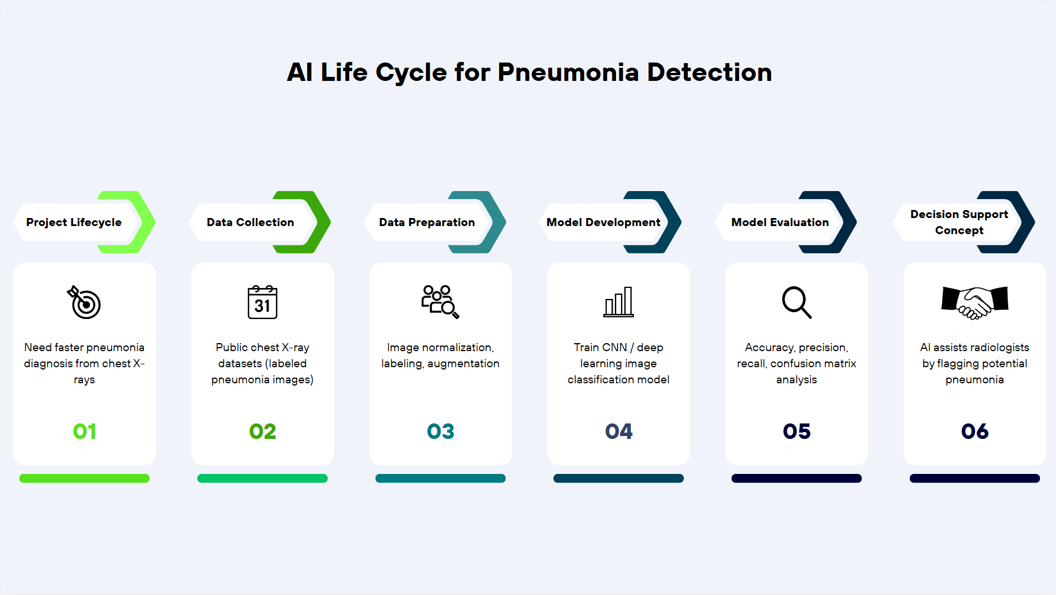

References
Boudi, A. L., et al. (2024). Ethical challenges of artificial intelligence in medicine. Journal of Medical Ethics.
Essa, M. E. A., et al. (2025). Diagnostic accuracy of artificial intelligence in chest radiography for pneumonia detection. Medical Imaging Research.
Fedorchenko, Y., et al. (2025). Ethical use of artificial intelligence for processing medical imaging data. Healthcare Informatics Journal.
Siddiqi, R., et al. (2024). Deep learning for pneumonia detection in chest X-ray images. Medical Imaging and Artificial Intelligence.
Usman, C., et al. (2025). Pneumonia disease detection using chest X-rays and machine learning. Algorithms.

